



Machine Learning

What Did We Cover Last Time?

Contents

The Problem Domain Explained

Publishing a Web Service – UI based

Publishing a Web Service – Jupyter Notebooks

Consuming a Web Service – in Excel

[OPTIONAL] Consuming a Web Service – in an App

Conclusion

Introduction

First Time Setup

The Data

Data Processing

Training the Model

Comparing Classifiers

Publish as a Web Service

Visualise Results

Conclusion

Extra Resources

What Did We Cover Last Time?

The previous lab intended to introduce you to the basic steps in building a Machine Learning model in the Azure Machine Learning Studio. We covered data input, data pre-processing, regression training, testing multiple models and evaluating them. Throughout your course you have also been looking at Jupyter Notebook as part of Azure Machine Learning.

This lab will carry on from the previous lab on Azure Machine Learning and look at publishing the regression model from within the studio to create an API, as well as via Jupyter Notebooks. Then review the sample code for a published experiment and test the output from an Excel add-in/application. Then finally look at how you can manage the usage of your machine learning models from the web service portal.

If you completed the last lab you can continue building on your experiment named ‘UCL ML Studio Lab’ or get the completed experiment from the gallery here: <http://gallery.cortanaintelligence.com/Experiment/UCL-ML-Studio-Lab-Publishing-Ready-1>

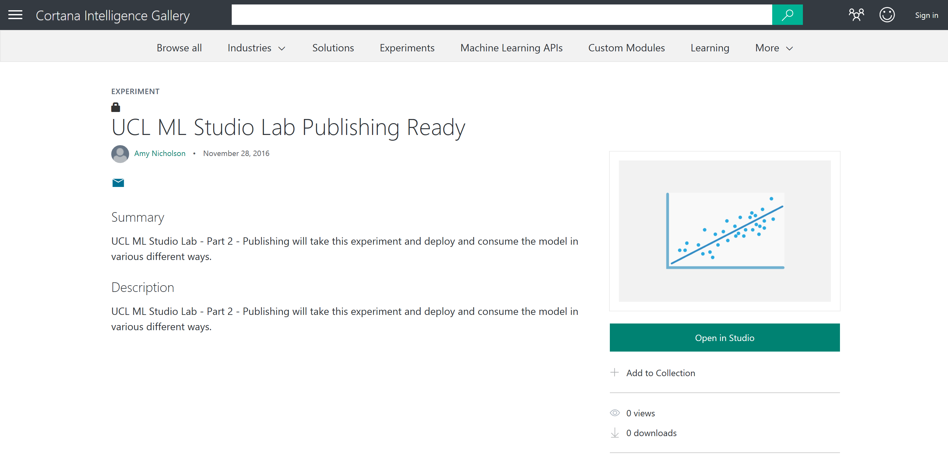

Choose ‘Open in Studio’ place into your workspace and ‘Run’ the model from the bottom toolbar before starting the rest of the lab.

The Problem Domain Explained

During the previous lab, we created and evaluated two models, that given past data collected about cars and their values, we predicted the price/value of a car given other attributes associated with the car:

* The attribute columns in the dataset include values such as the model/make, fuel type and body style as well as performance values such as MPG, horsepower and engine type
* The value we were trying to predict is the price of the car. In this dataset, the values range from £5,000 to £45,000.

We retrieved data from an Azure Blob Storage account and started to pre-process the dataset ready to train a machine learning model. The model we created is a form of supervised learning so we used historical car attributes and values to predict the price of future cars we might receive. This model performs a regression algorithm to try and predict the actual price of the car with the lowest amount of error, for example £16,595. This information is in the sample data in the ‘price’ column.

Now assume we are happy with our car prediction model and we want to build this capability into our applications, we need to be able to deploy the model. In this lab we will create a scoring experiment and deploy a model to create an API that we can call using a HTTP request.

Publishing a Web Service - UI

We have trained a model to predict a car’s price given some attributes of the car, with the least error possible (a regression experiment). Now we want to use one of Azure Machine Learning’s key features – Deploying the model, by publishing an API to expose the model we have created.

We have the ‘UCL ML Studio Lab’ experiment ready to be published and should look something like below (every module should have green ticks next to it):

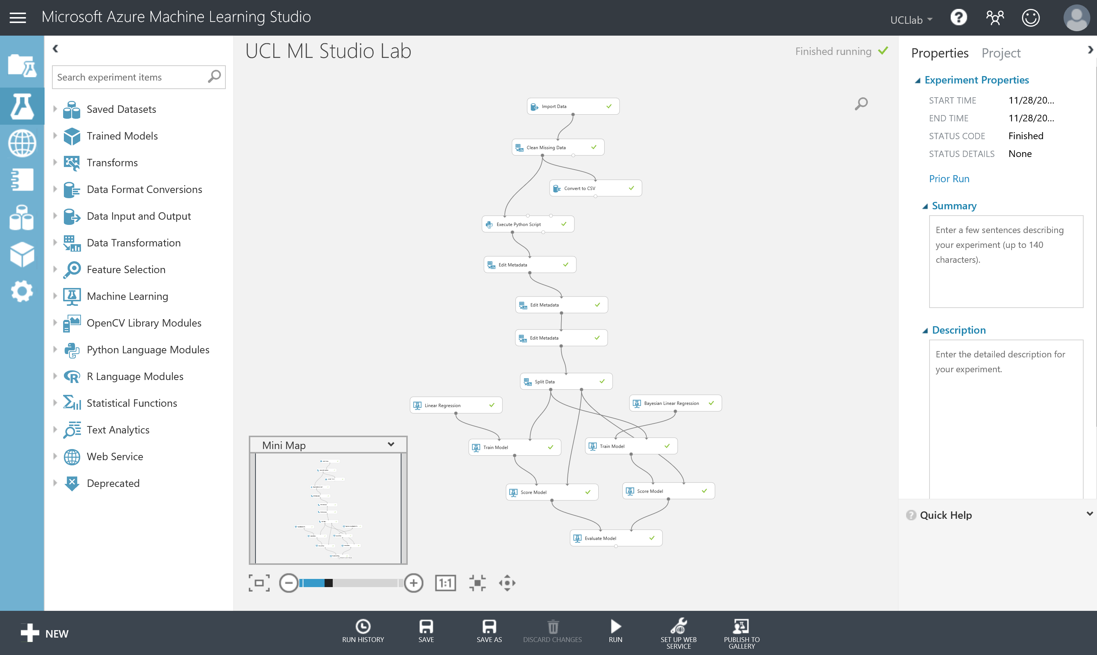

This model can then be published to the Azure ML Web API service to make it available for other users or applications to use as a web service or a REST endpoint.

This may sound like a hard task, however once your experiment has been run successfully - you will see a button on the toolbar at the bottom of the screen become active:

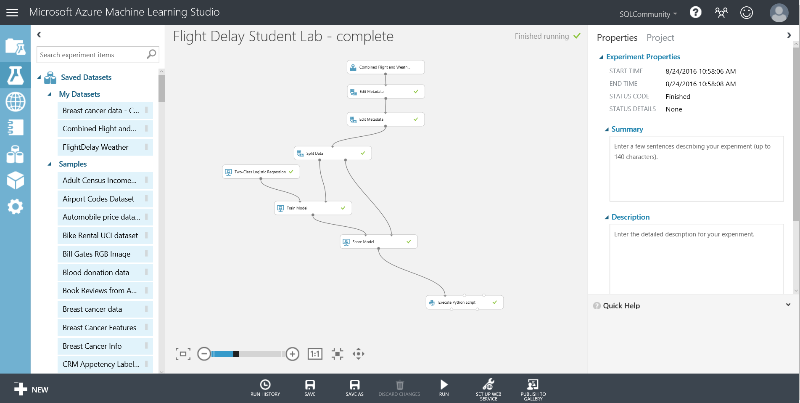

Select the train model module in your experiment associated with the Linear Regression model, then choose **‘Set up web service’** and choose the **‘Predictive Web Service (Recommended)’** option on the bottom tool bar. From here our experiment appears to get redrawn and consolidated. What has really happened, is that ML has created a new Predictive experiment tab at the top of the screen.

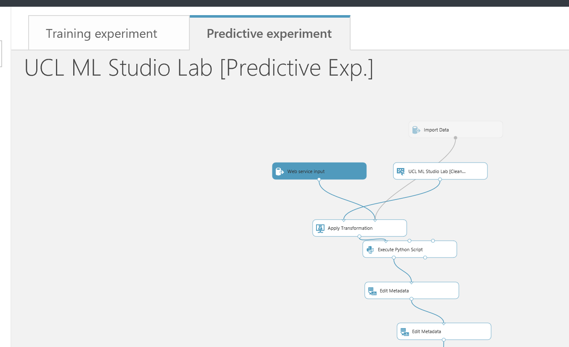

Our original experiment is still there, but is in the Training experiment tab. Click the training experiment tab to see this in action.

What is a predictive experiment and why do we need it? The purpose of the predictive experiment is to use your trained model to score new data, with the goal of eventually becoming operationalized as an Azure Web service. This conversion is done for you through the following steps:

* Convert the set of modules used for training into a single module and save it as a trained model
* Eliminate any extraneous modules not related to scoring
* Add input and output ports that the eventual Web service will use

The added input and output ports, “Web service input” and “Web service output”, respectively represent the data format that will flow into and out of the web service we are creating.

While the wizard has done a basic job of placing where it thinks the input and outputs on our predictive experiment are, it is not perfect. We will need to think about the usage of our API and the data we will receive from an application for example. In our case we will assume we receive only the data we need to query the API and that the data has been input checked before querying the API. Therefore, the scoring experiment does not need to perform all of the data transformation steps we performed in the training experiment to get the data in a format to train.

Move the ‘Web Service Input’ module down the experiment and connect to the input of the ‘Score Model’ module. Your experiment should now look something like below:

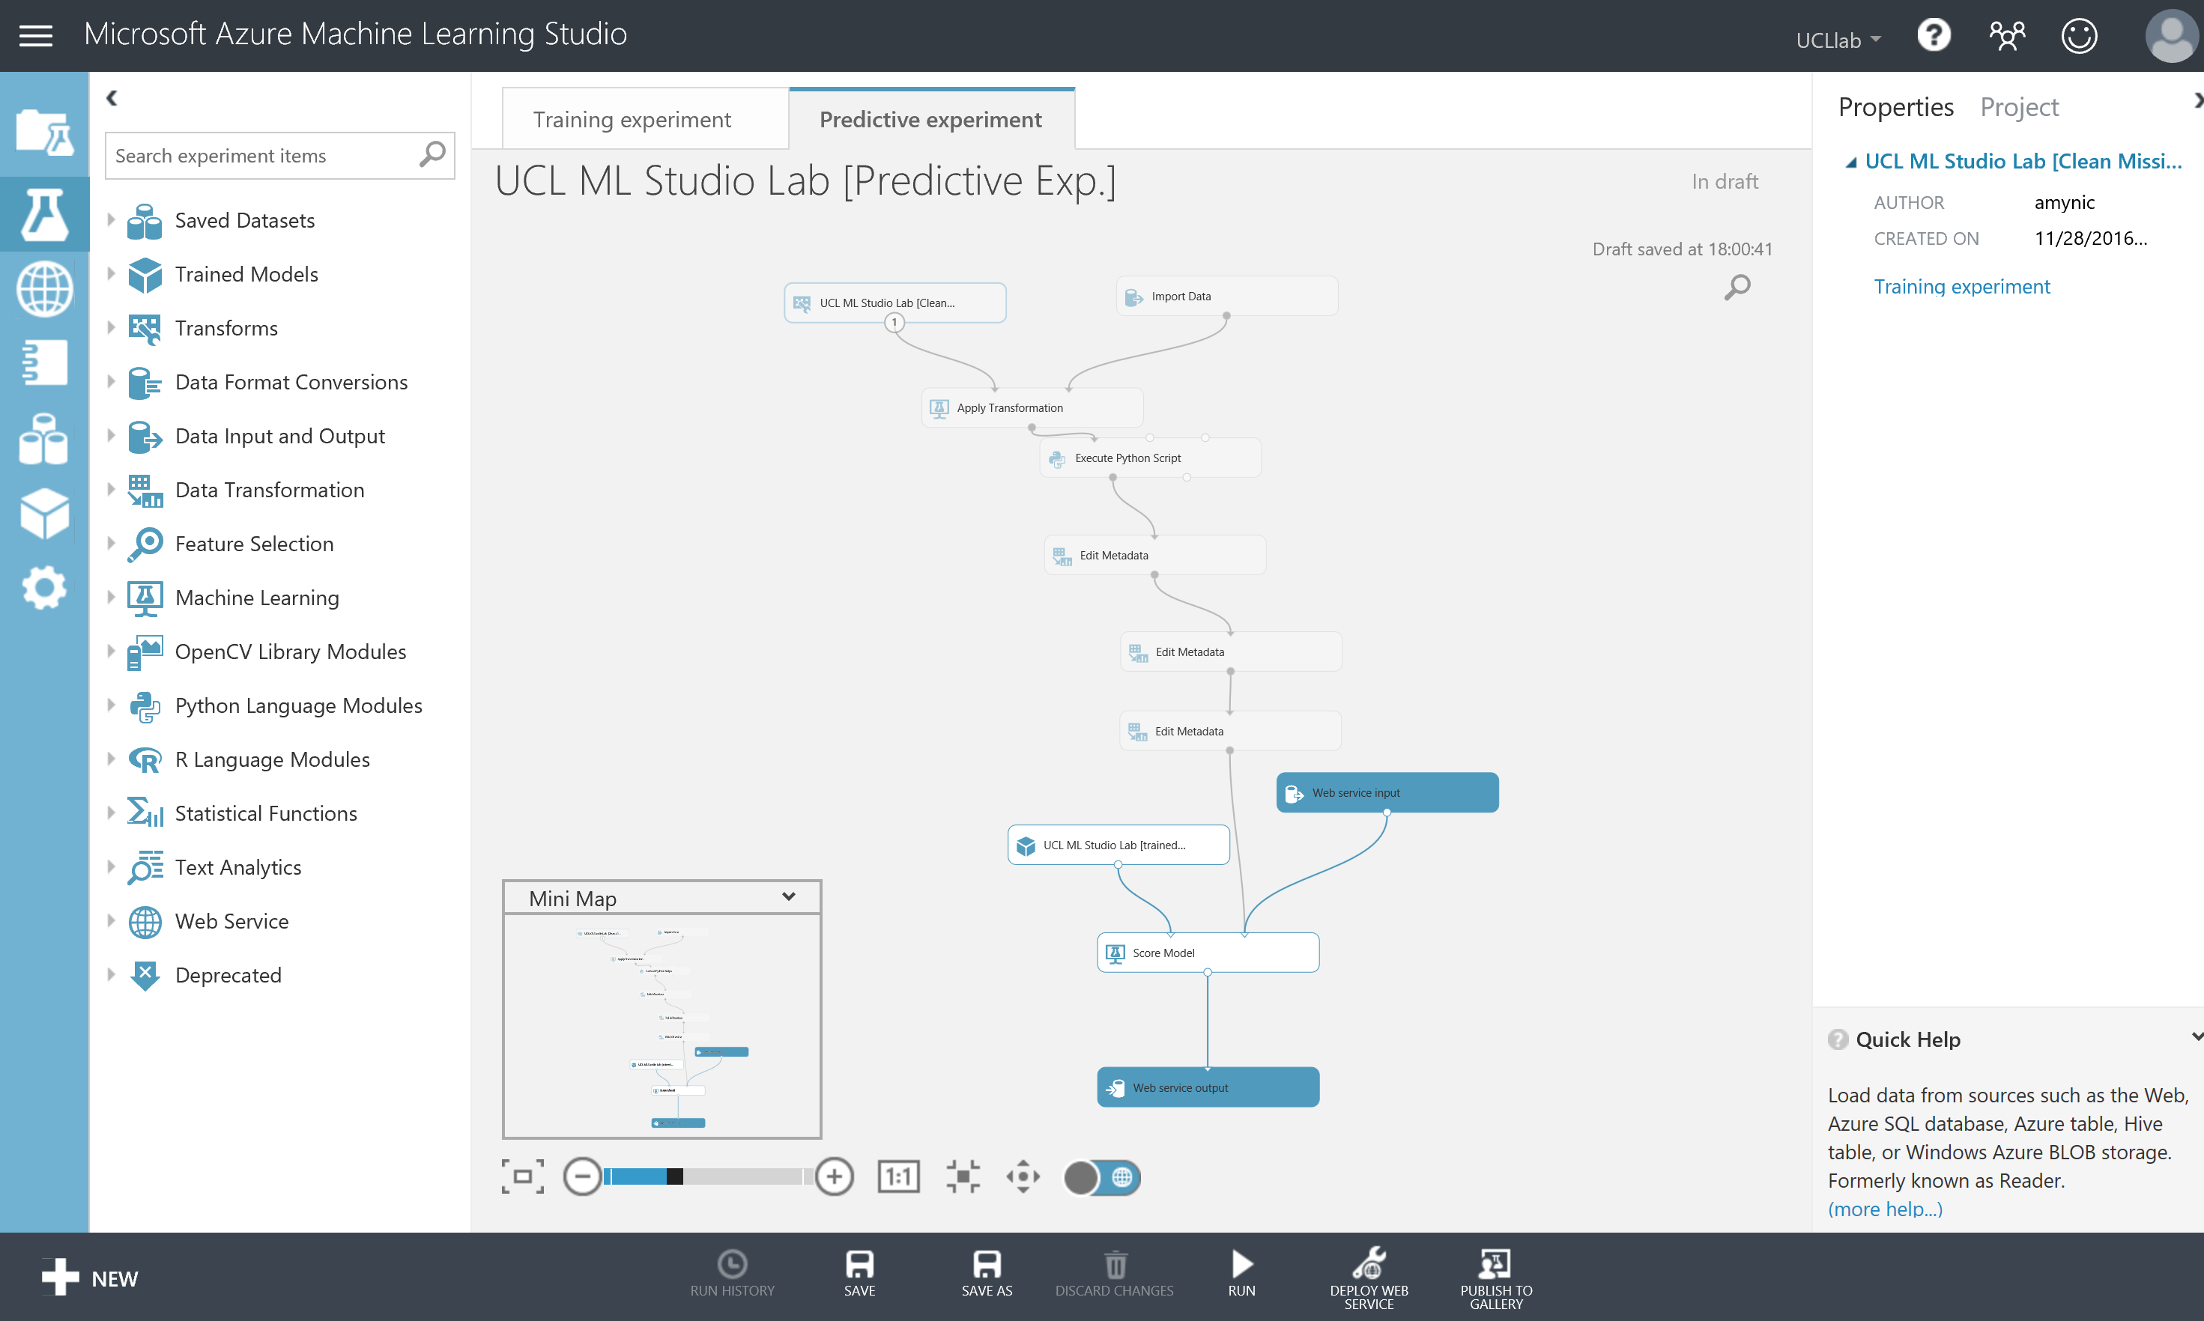

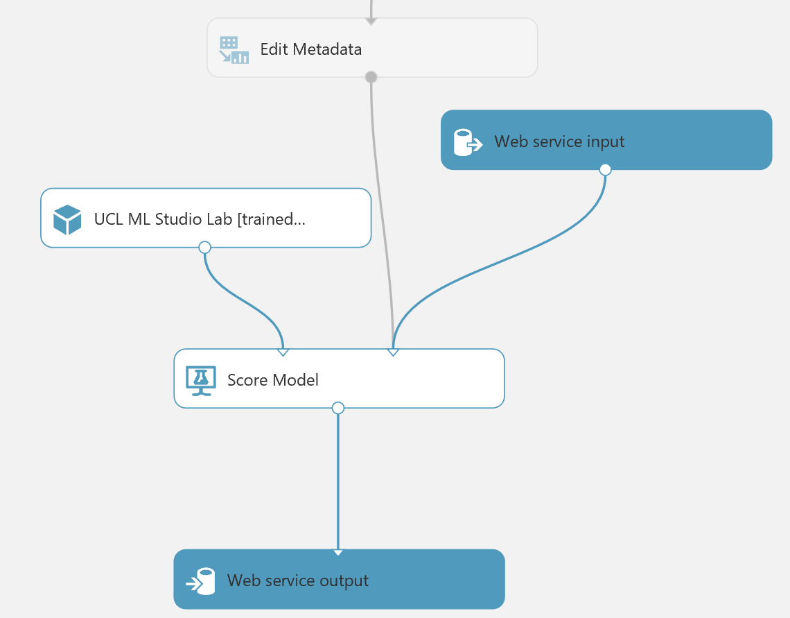

The data flowing through the grey path, from Edit Metadata to Score Model, in the above diagram, now contains the schema of the input to our web service. Run this experiment and then right click and visualise the output of the Edit Metadata module.

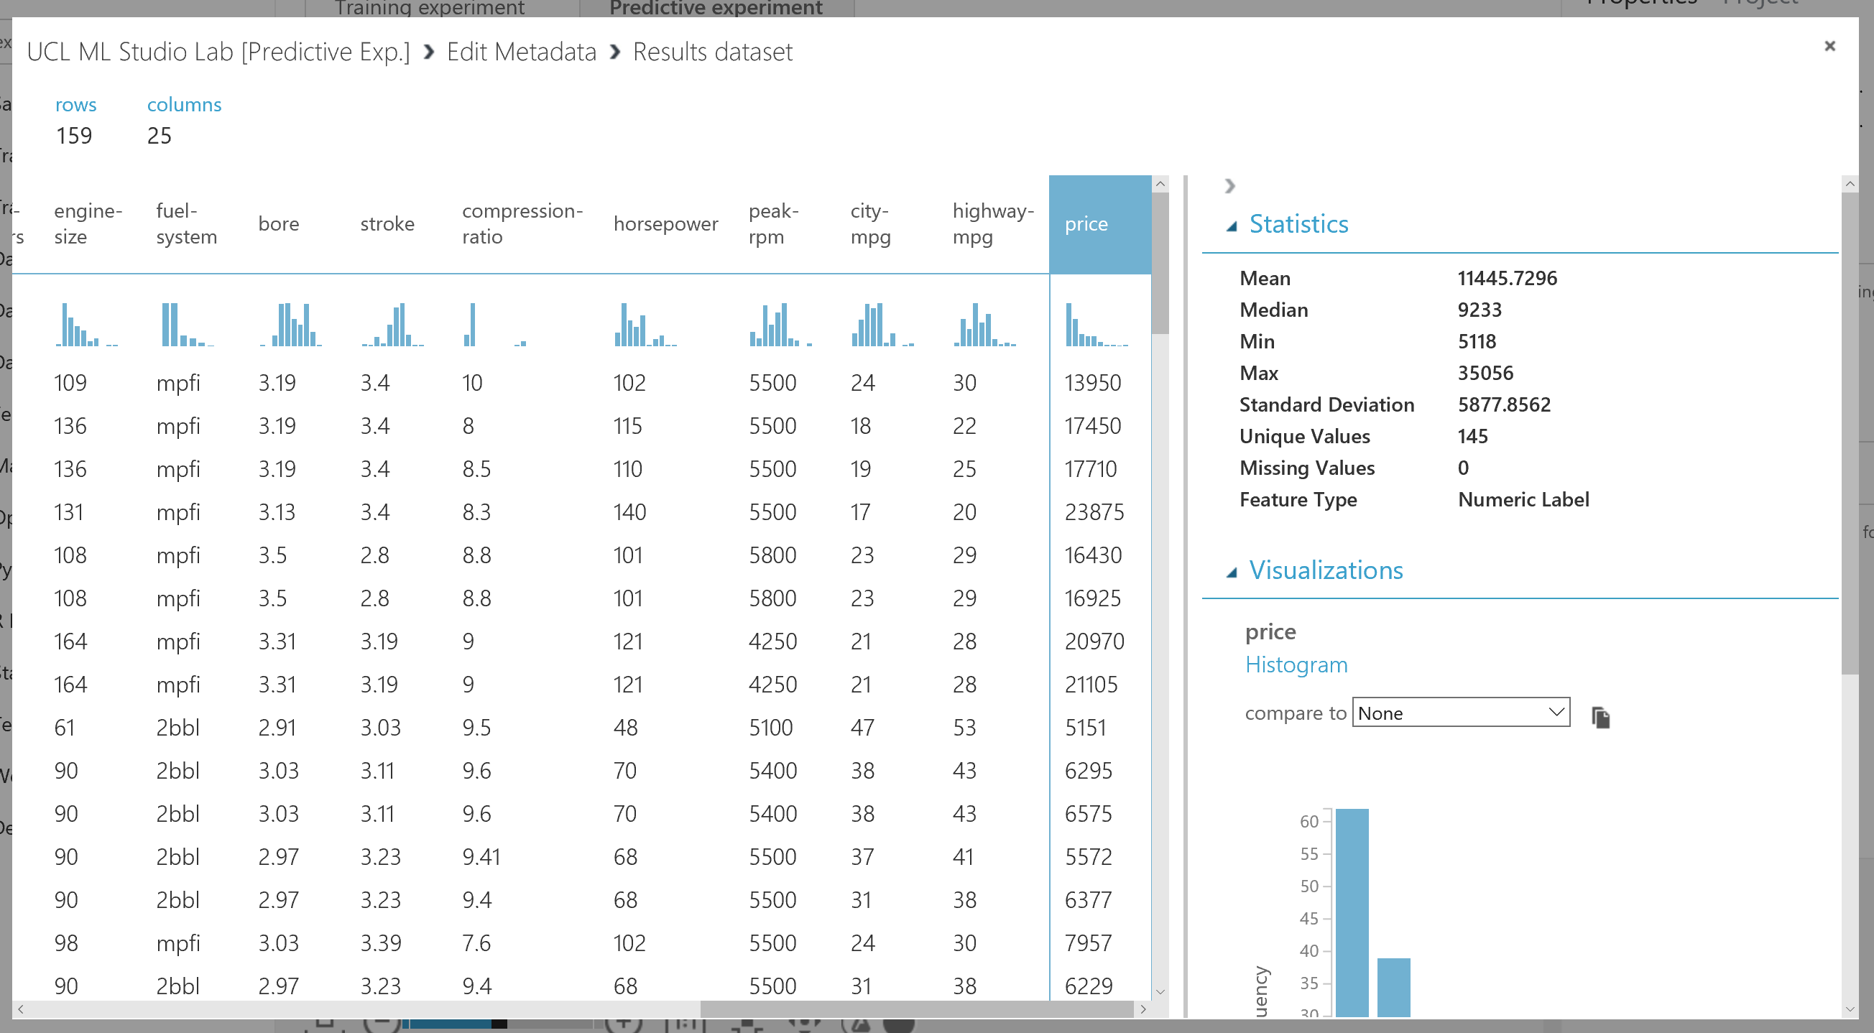

All the columns look fine, it is the right data and the data is transformed as we expect from the training experiment, however note: the data contains our label (price) which is what we are trying to predict. While this is valid for training we shouldn’t have it here for scoring – as this is the outcome/value we want to pass back as an output from the web service, moving from training a supervised machine learning model to scoring/deploying a supervised machine learning model.

So we can eliminate this column by adding a ‘Select columns in a Dataset’ module as shown below that excludes all labels from the experiment:

*\*\* remember this will mean that the schema for the wbe service input going into the score model module only contains your features(dimensions) \*\**

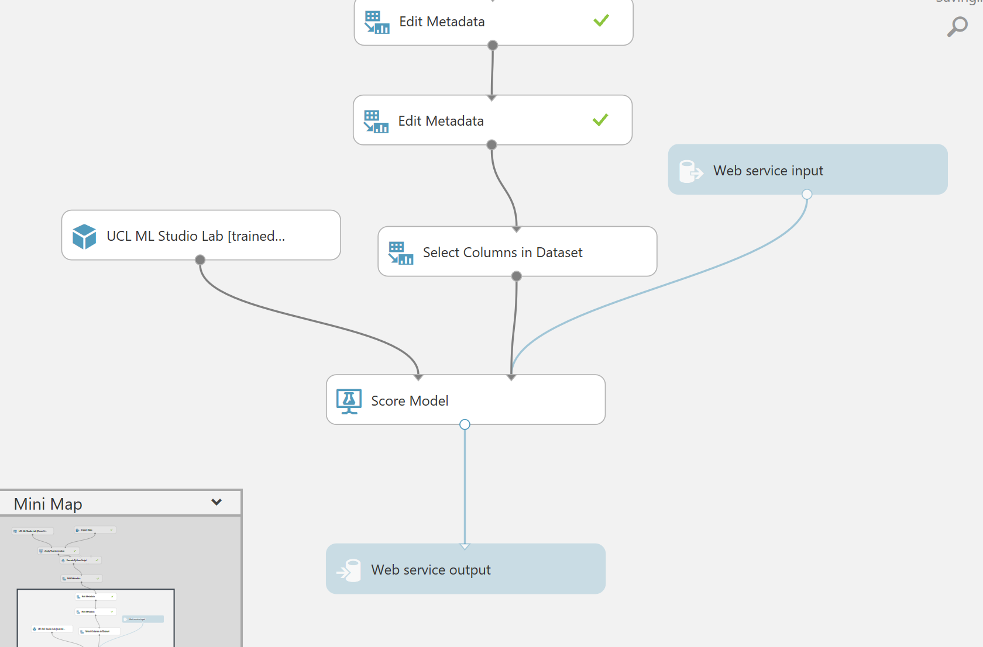

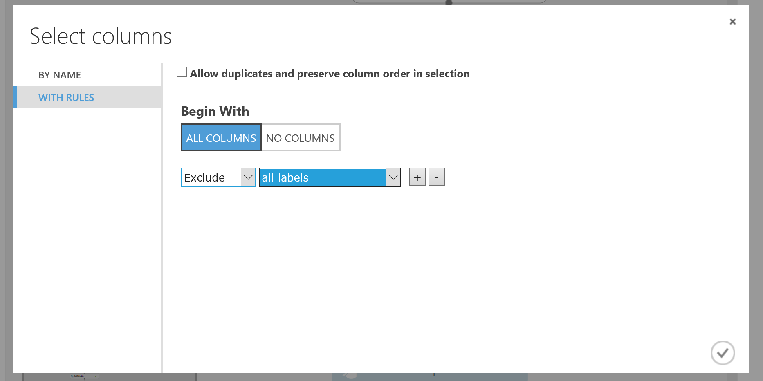

If we now think about what fields we want to return to the application or web site that will call our web service we are creating, then all we technically need is the scored label (the prediction) for the regression experiment. This makes an assumption that we keep hold of nay data needed on the front end to understand the information/prediction that will be passed back from the web service.

So we should add another ‘Select columns in a Dataset’ module as shown to just return that field:

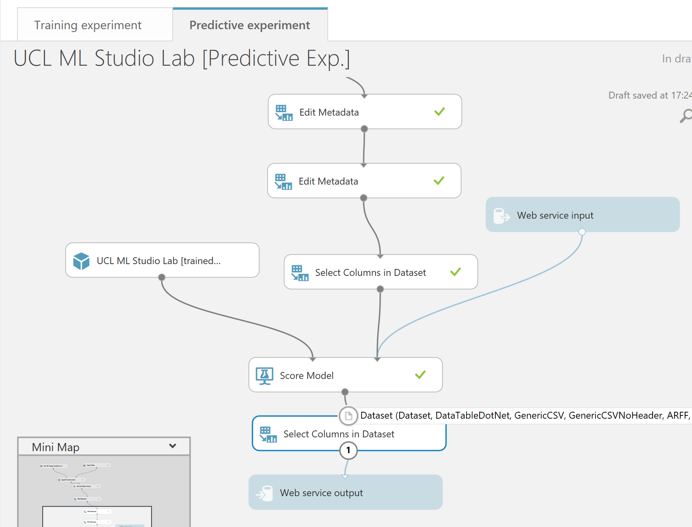

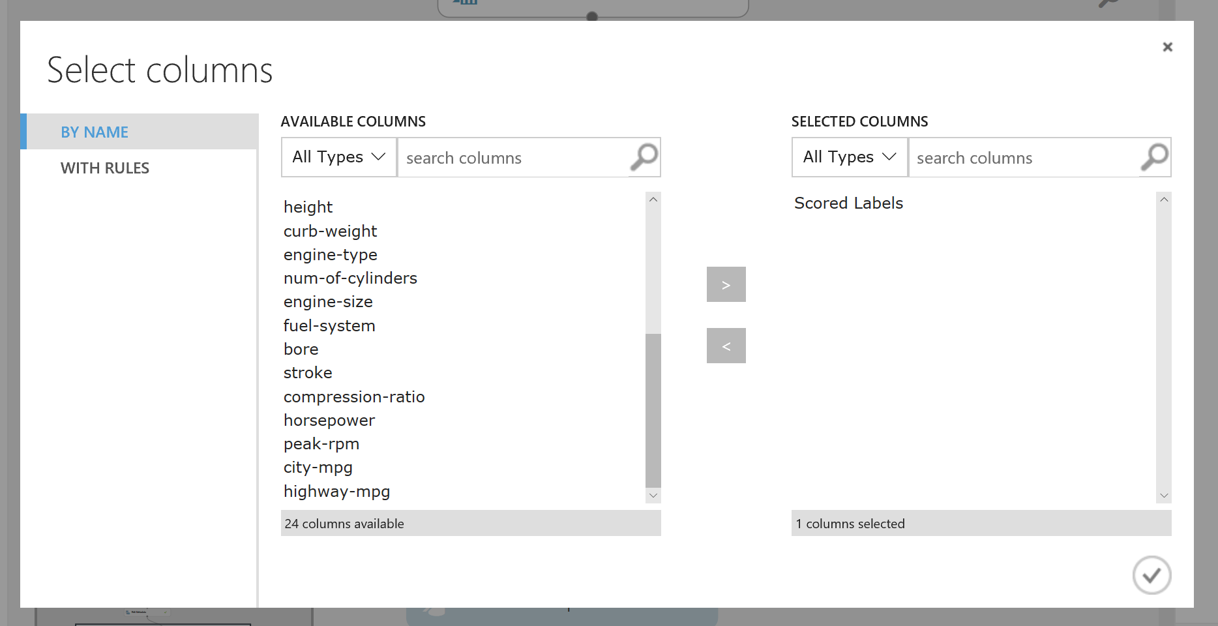

We must now **Run** this predictive experiment as this allows ML to validate the predictive experiment before we can publish it as web service, choose the **RUN option** from the bottom toolbar.

After a successful run we’ll see that the deploy web service icon is available on the bottom toolbar



All we need to do is click on it and select deploy web service (new).

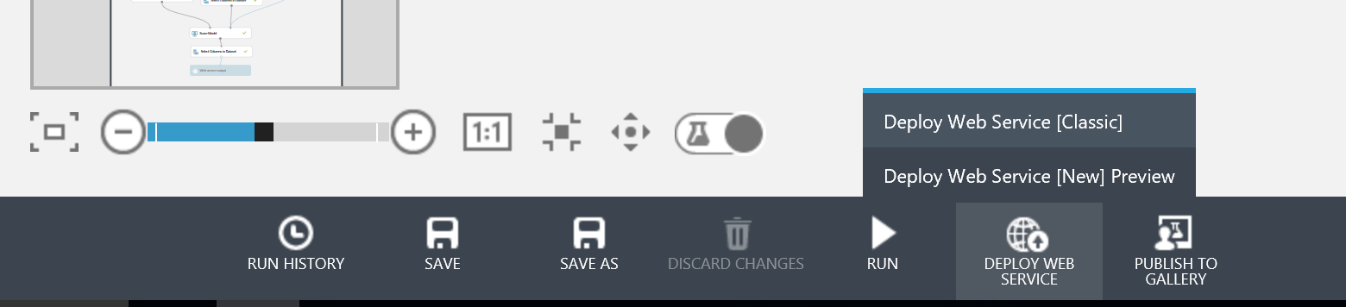 After a few seconds we’ll be taken to a new tab in the browser and into the web service management portal for azure machine learning.

In here create the name of your web service (see example below) and choose the free pricing tier.

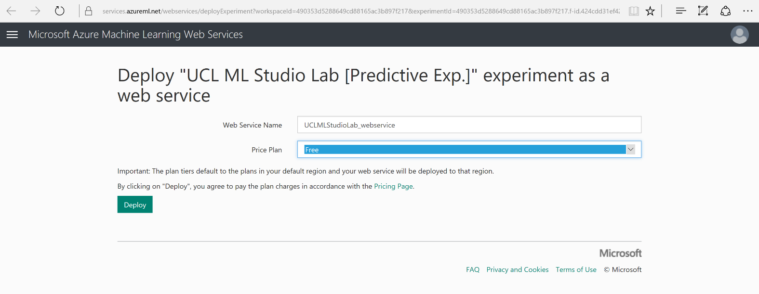

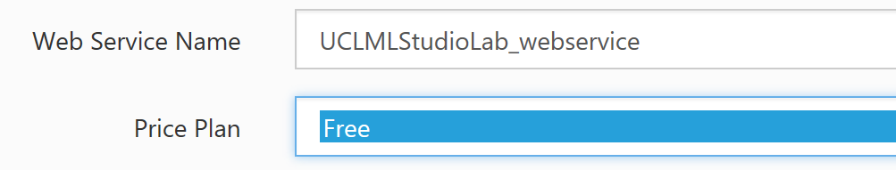

Click the deploy option and wait for the web service management portal to load with your web service information:

*\*\* Note: if there is an initial swagger API error, wait a couple of minutes and then refresh the page\*\**

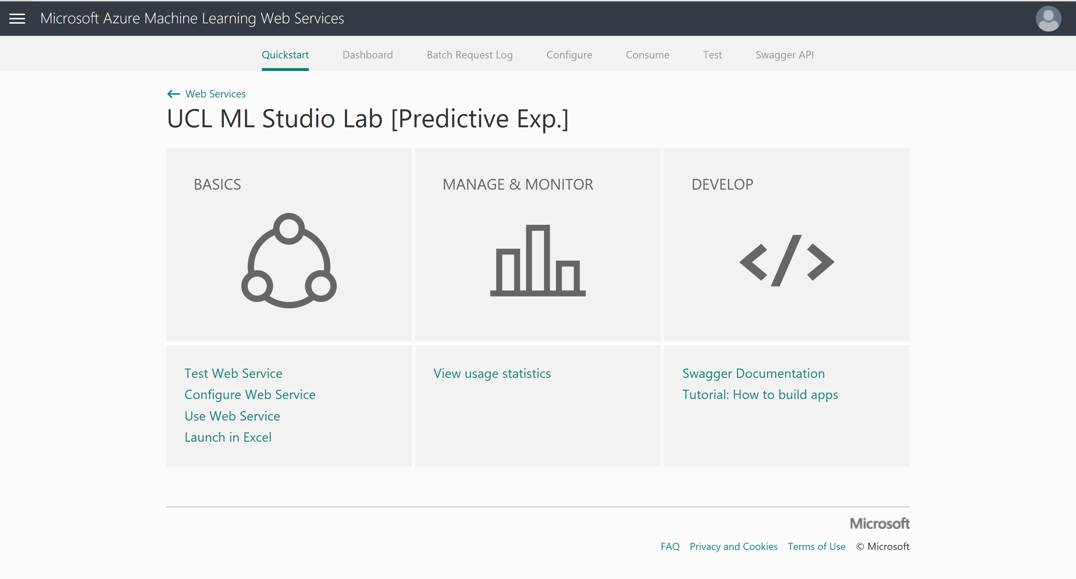

Next we need to configure our web service in order to test it. Click on ‘Configure Web Service’ under the BASICS section. Once open give your web service a description and make sure ‘Sample Data Enabled?’ check boxes are set to yes. Then save these changes.

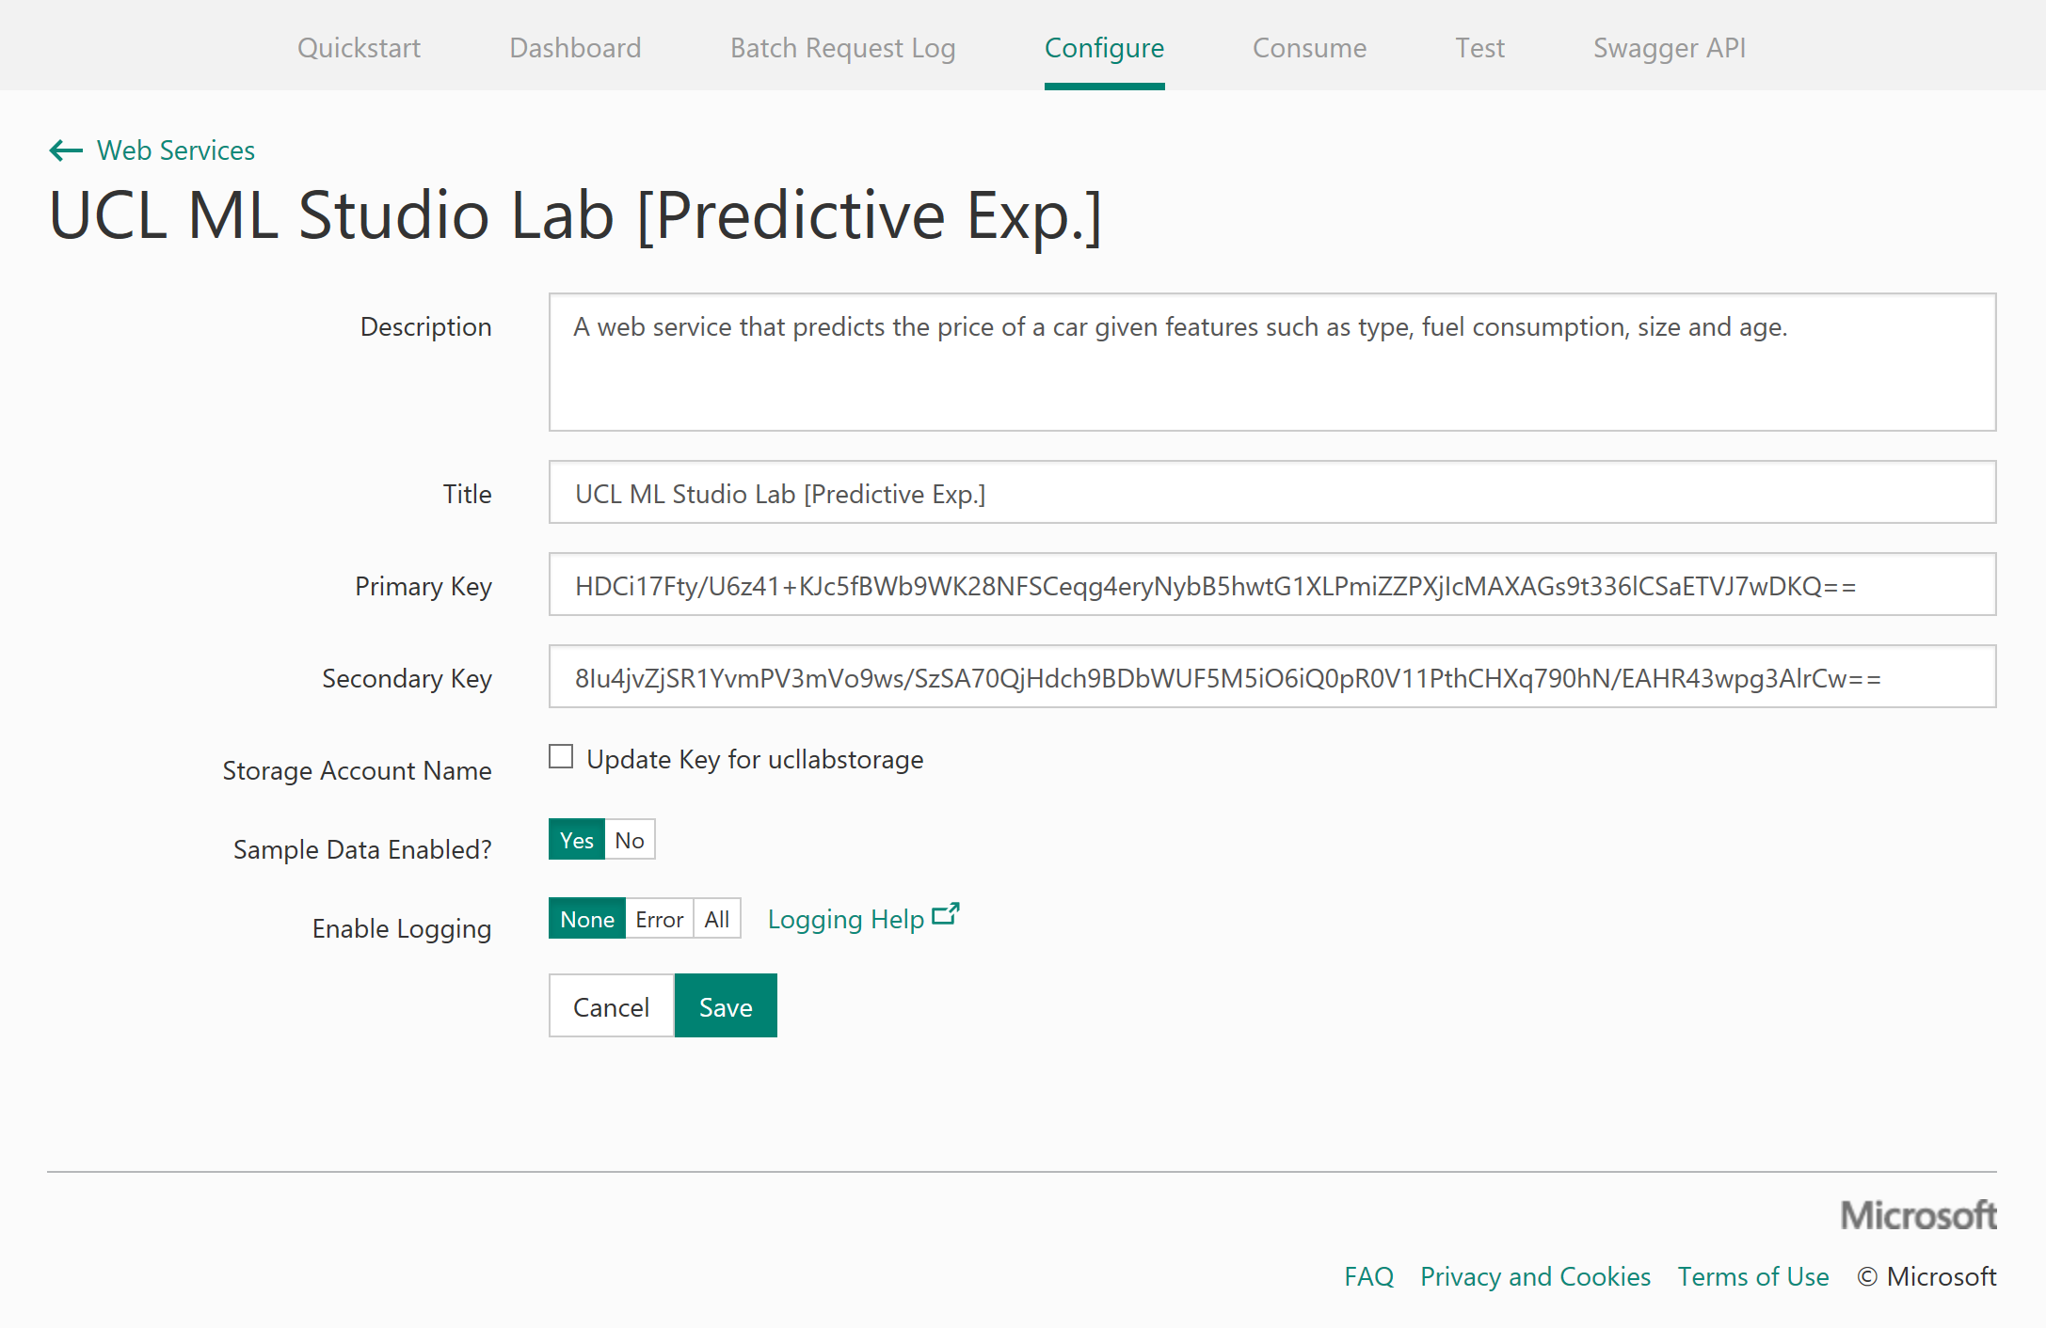

You should receive a message stating the update was successful:



Now let’s test the web service to check our input and output schema. Choose Test in the top toolbar and notice that for Request Response option is selected and our sample data has prepopulated our input data.

Check the input schema is as expected (not containing the label, price) and select the Test Request Response button to return your prediction on the right (output schema of web service). In the screenshot below, the Audi is predicted to cost around £15600.

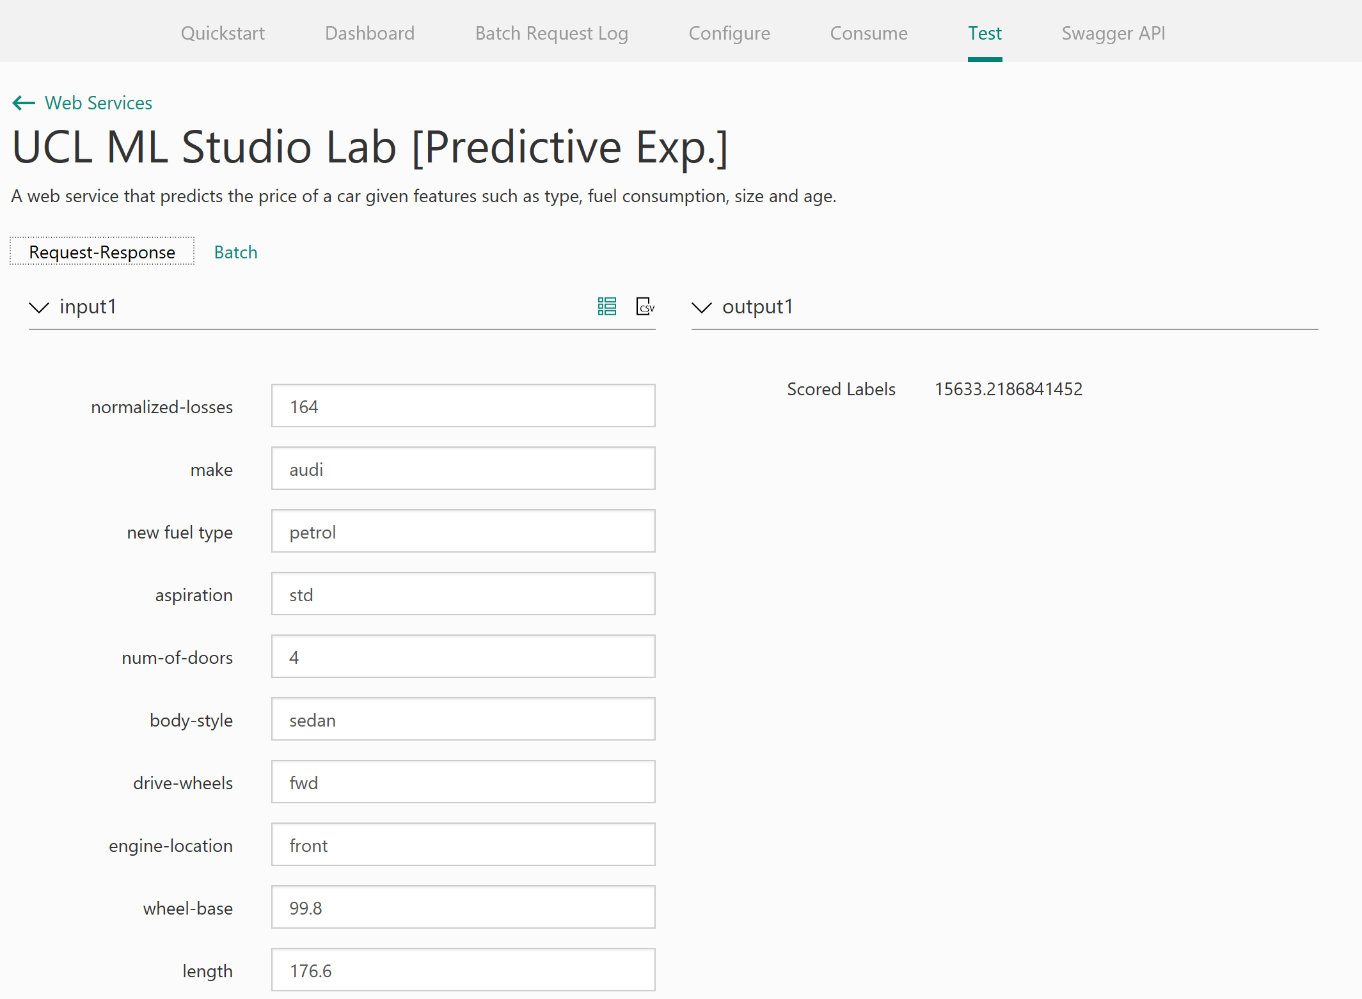

You can also test batch files of data to receive multiple predictions back. Select the ‘Batch’ Option for testing in the test web services panel

Now upload the ‘sampleTestData.csv’ available on the GitHub repository from your local machine and click the Test button.

Notice the job gets queued, tells you the status, start run time, end run time and duration of the job.

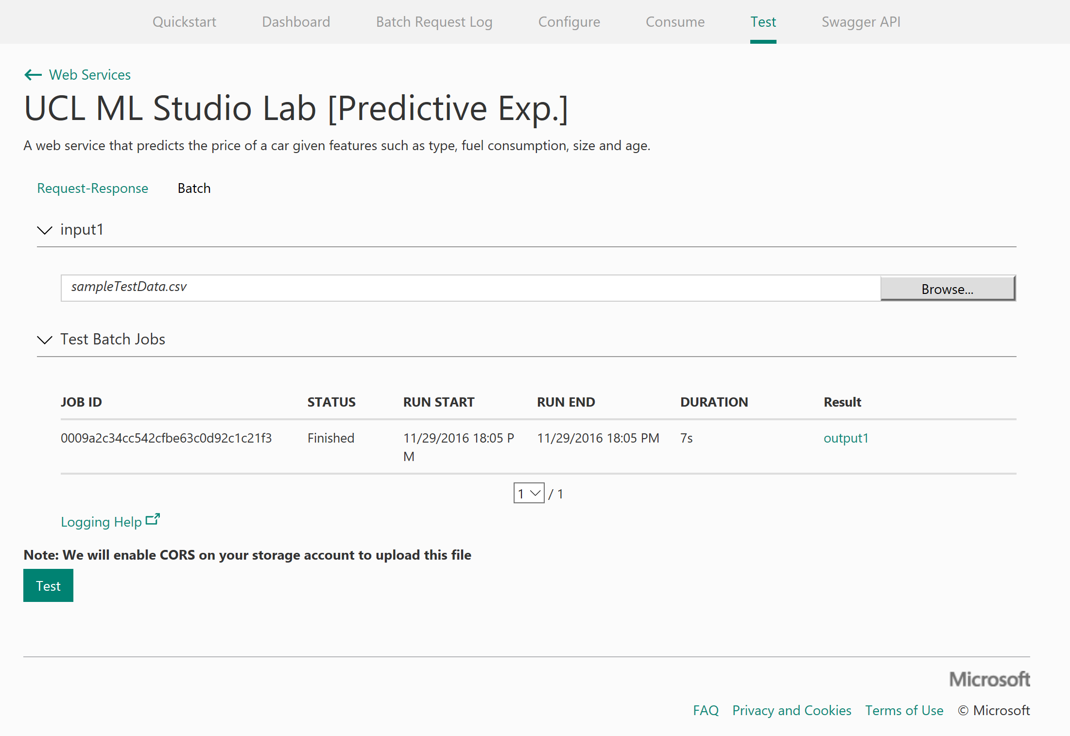

Select the output1 link and download the CSV, once downloaded open the CSV file and find the scored labels output for each of the cars.

Other features to quickly note. You have a ‘**Dashboard’** of usage of you web service API on the dashboard tab:

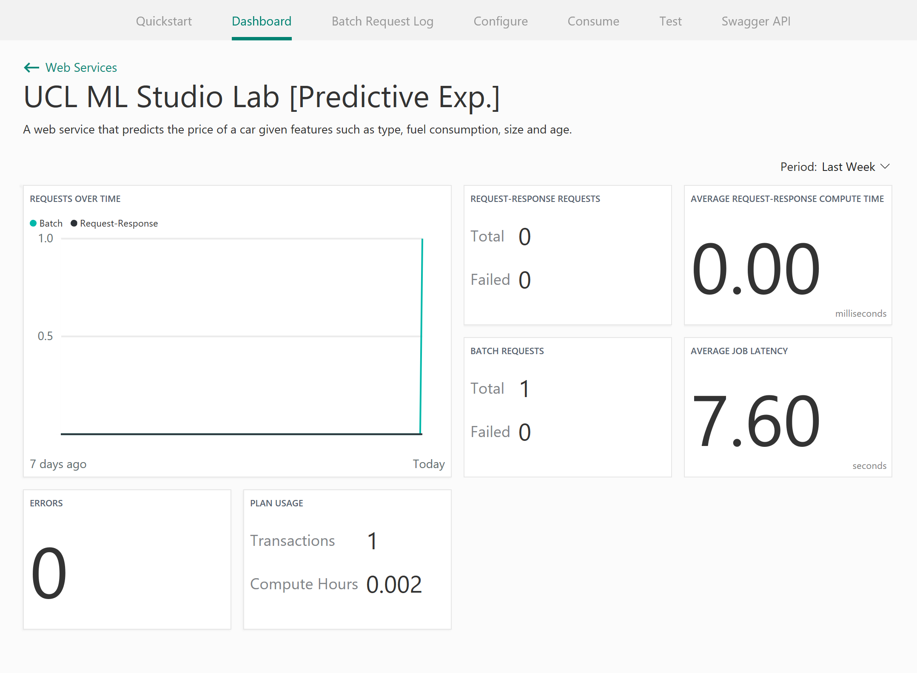

Finally, the ‘**Consume**’ tab provides your web service API keys, excel spreadsheets with your model preloaded and also sample code in C#, Python, Python 3+ and R to implement into your applications.

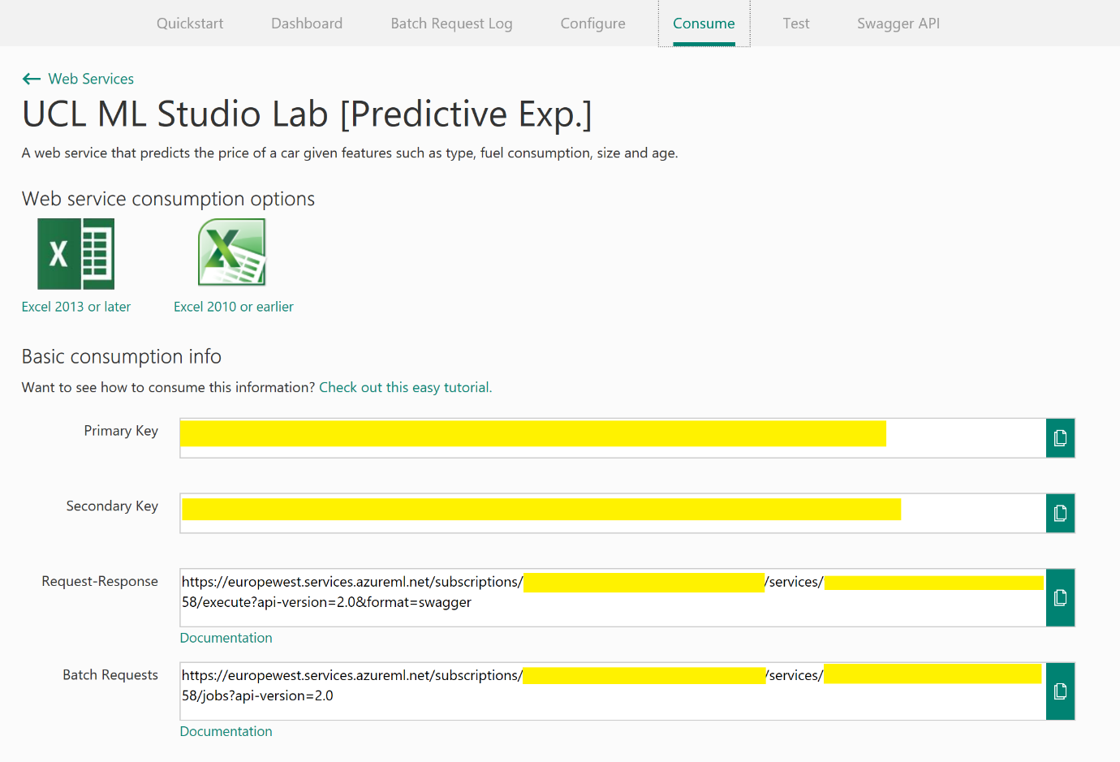

Publishing a Web Service - Jupyter

You can also publish web services directly from Jupyter Notebooks as long as you have an Azure ML Workspace ID and Authorization Token, we can get these from your Azure ML workspace.

Go back to the Azure ML Studio and enter the settings tab

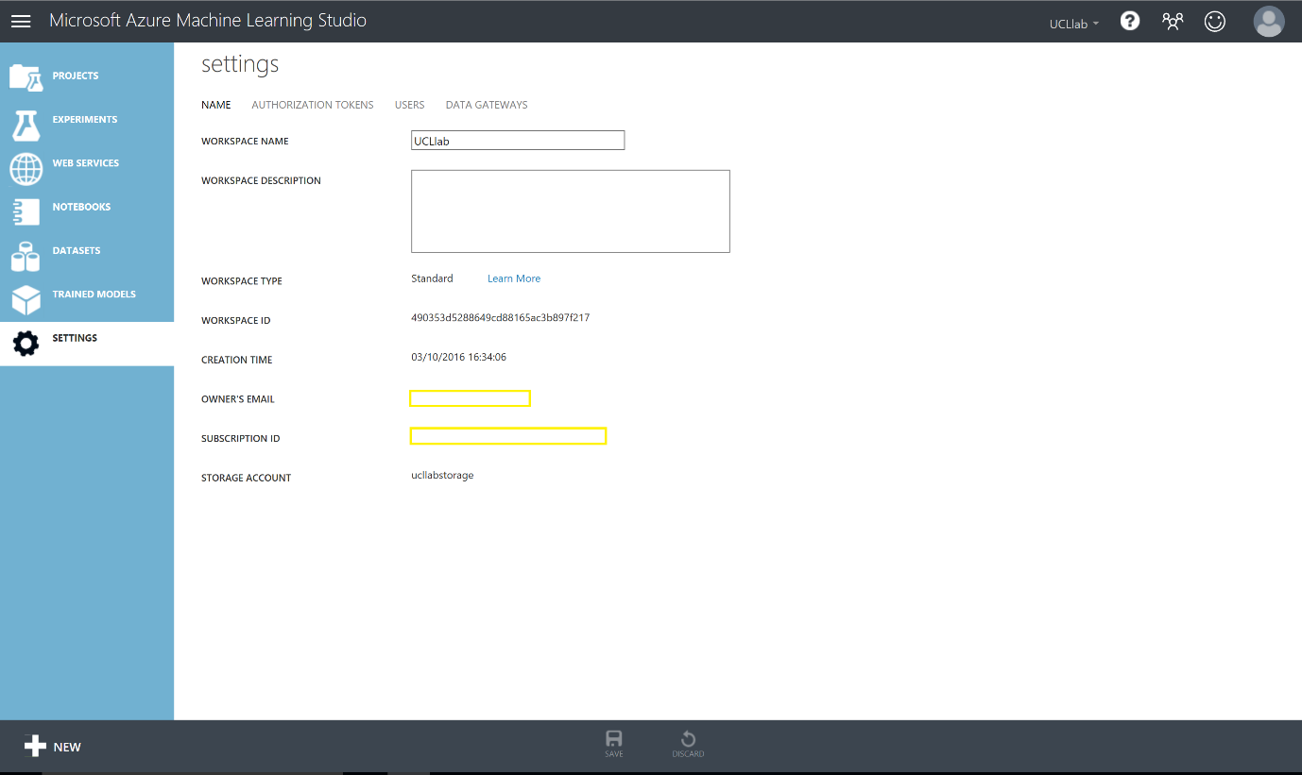

Take a note of your workspace ID from here and then enter the Authorisation Token header and take note of your Primary Authorisation token. You will need these later on in the lab.

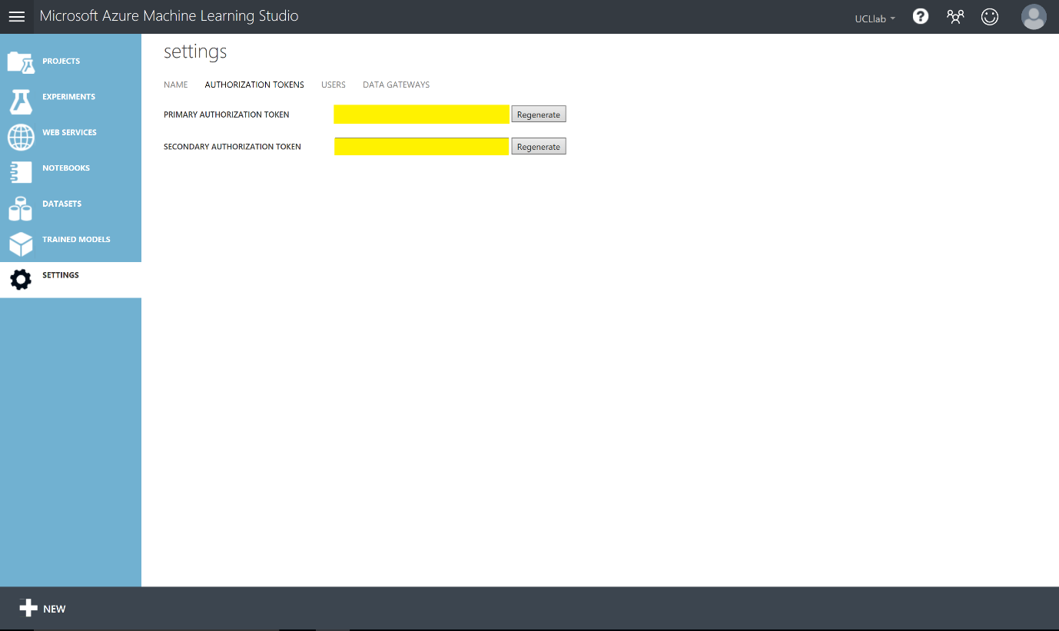

Now create a new Python 2 notebook from the New menu in Azure ML Studio

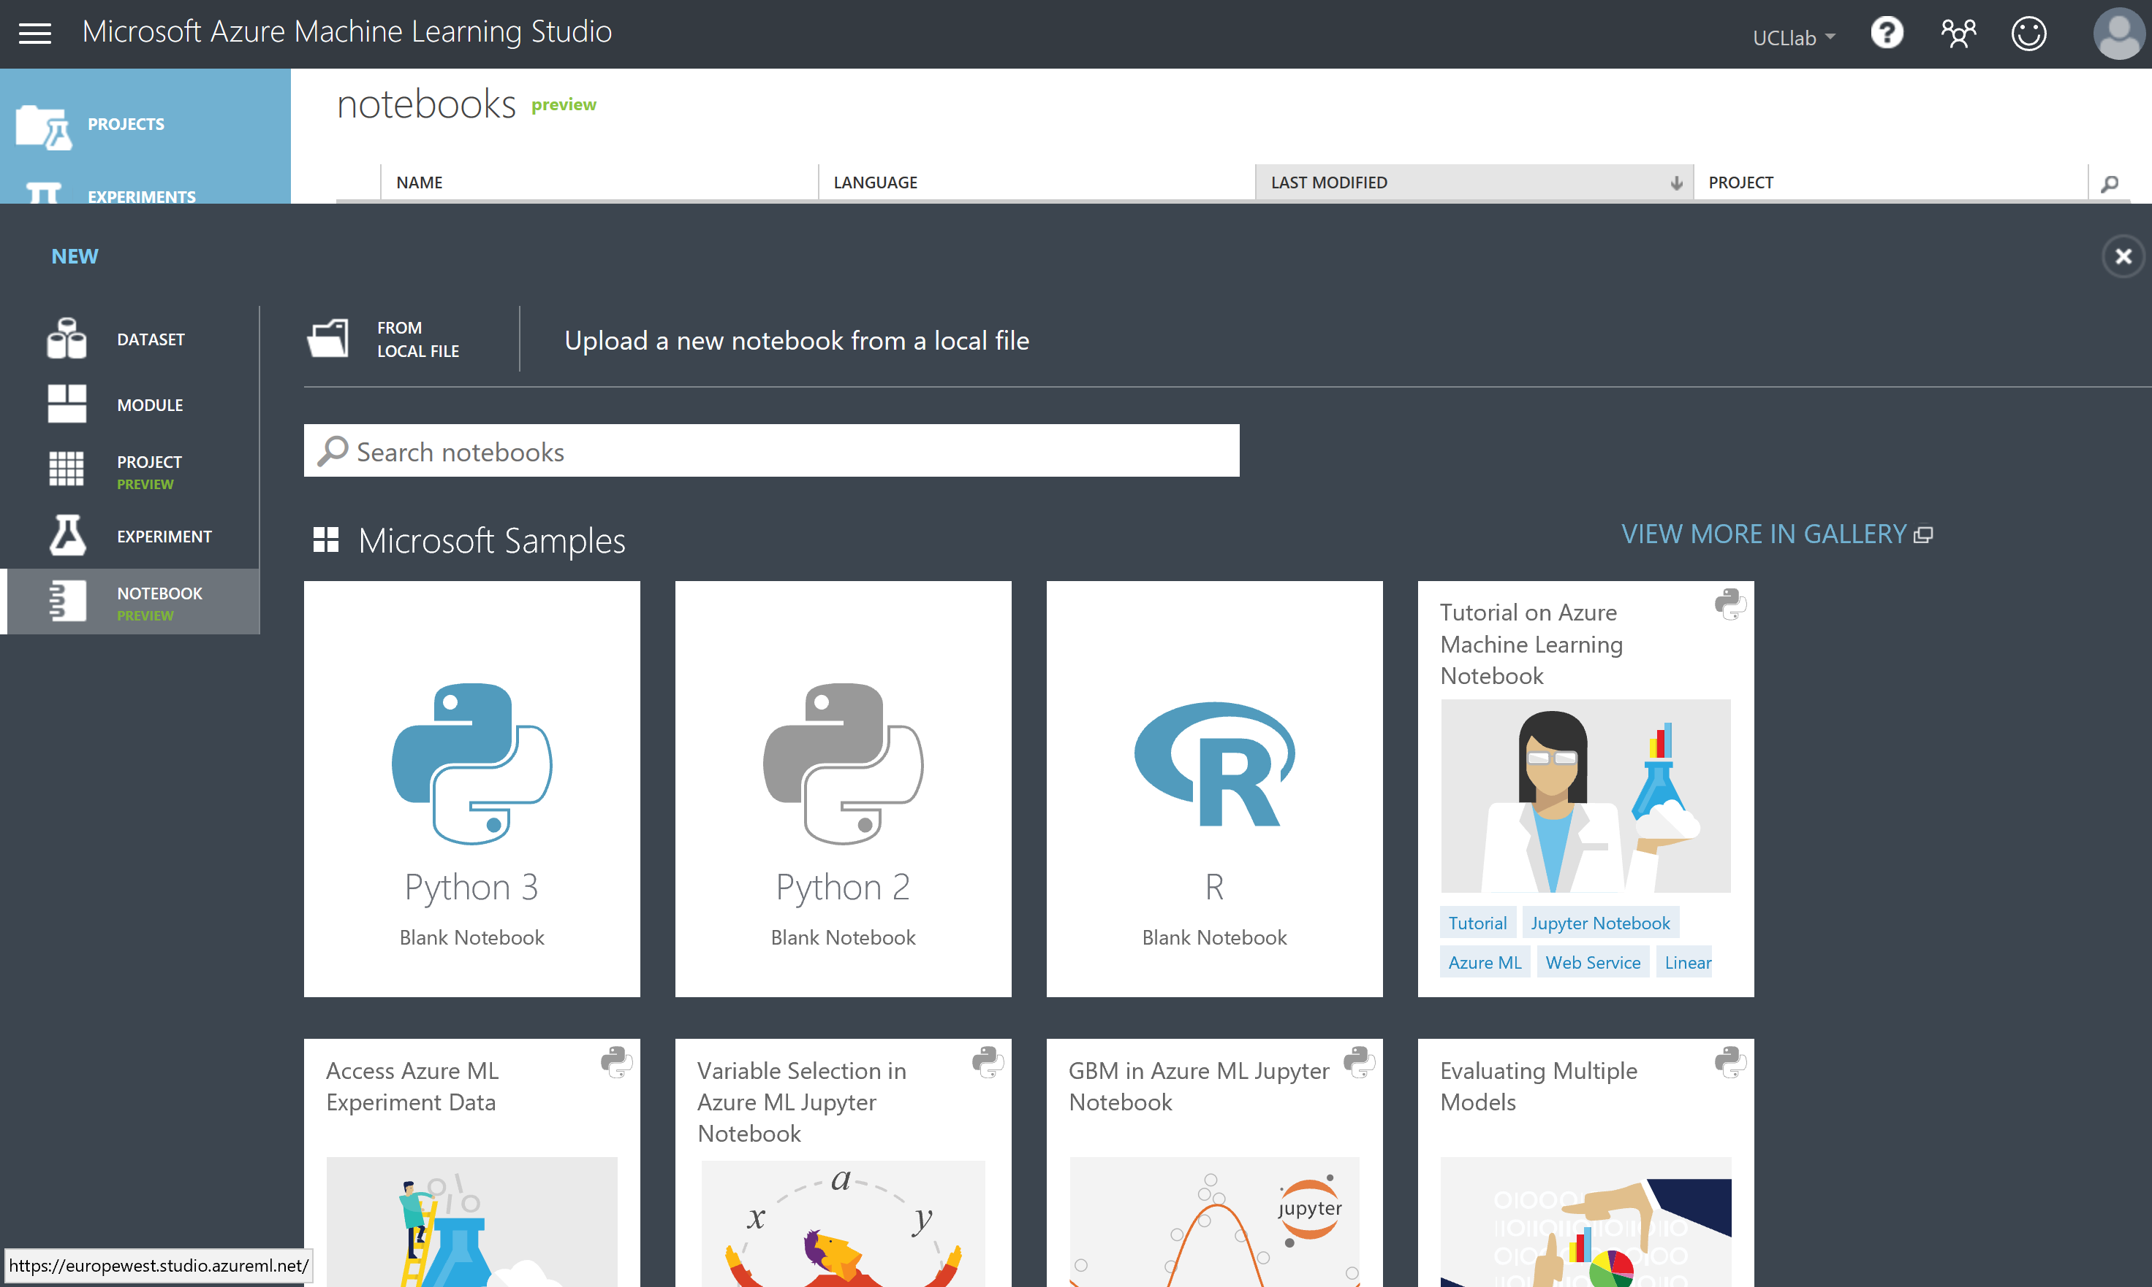

Give it a name like below: Azure ML Web Service Example

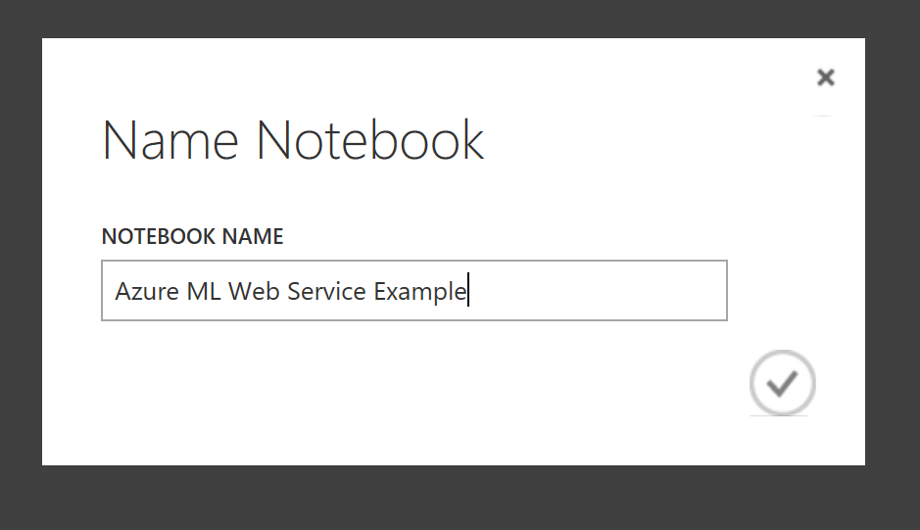

Because we are inside the Azure ML Studio notebooks **we will not need to install any packages**. However, if you are using other versions of Jupyter Python notebooks you will need to download the Azure ML SDK here: <https://pypi.python.org/pypi/azureml/0.1.1> and use a pip install command to be able to setup web services

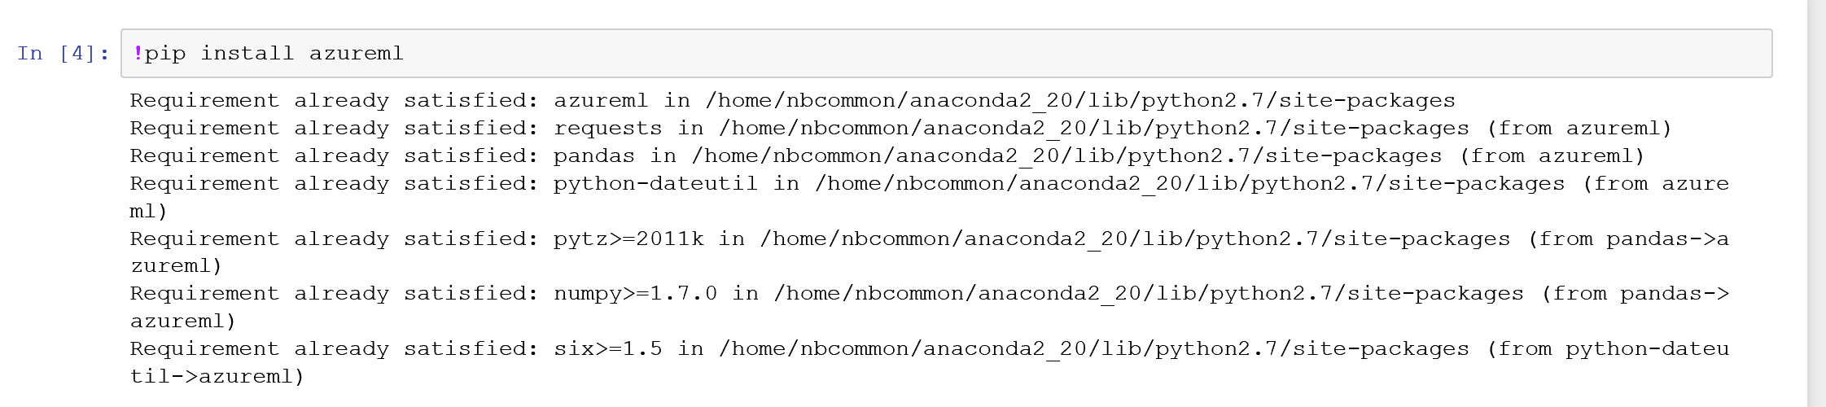

Next we need to import the services package and your credentials from earlier in the lab (workspace ID and authorisation primary token).

Enter the code below and substitute in your keys:

from azureml import services  
#Use your own workspace information below!  
@services.publish('<you workspace id>', '<your auth. token>')  
@services.types(a = float, b = float)  
@services.returns(float)  
def myfirstservice(a, b):  
    return a / b

this code creates a web service which returns a float value from the function definition ‘myfirstservice’. Run this code in the notebook (ctrl + enter).

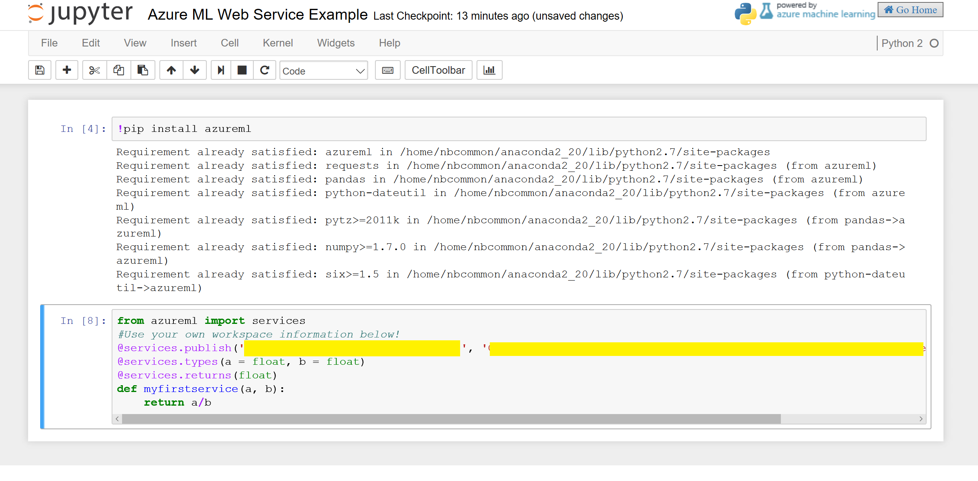

Once it is published you can run many commands over your service for example a few are below:

* Get Directory

Dir(myfirstservice)

* Post URL for the web service

Myfirstservice.service.url



* Web service help page

Myfirstservice.service.help_url



To call you web service function inside notebooks you can simply use the function definition, service, then followed by parameters *(note the first time you run the service it may take up to 30 secs to connect)*

Myfirstservice.service(4,2)



In this section we saw how we could use the Azure ML Python SDK to create and call python functions as web services hosted in Azure ML. This is a very simple example of a web service – however you can see how you could extend this to create more complex functions that you can call via an API

Consuming a Web Service – Excel

Consuming a Web Service - App

Optional Exercise – create a Web Site using the API

We can also test our new api using a partially configured web site in the [Azure Web App Marketplace](https://azure.microsoft.com/marketplace/web-applications/all/). Simply go to the site and look for Azure ML.

This will create a web app in our azure subscription.

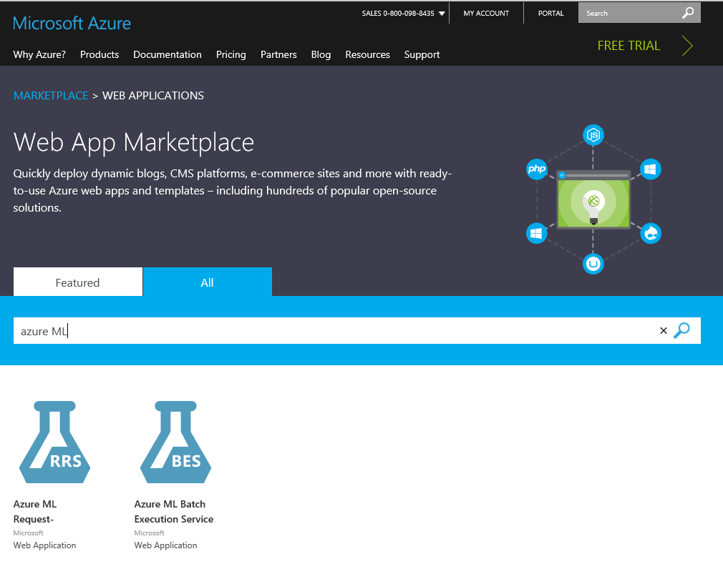

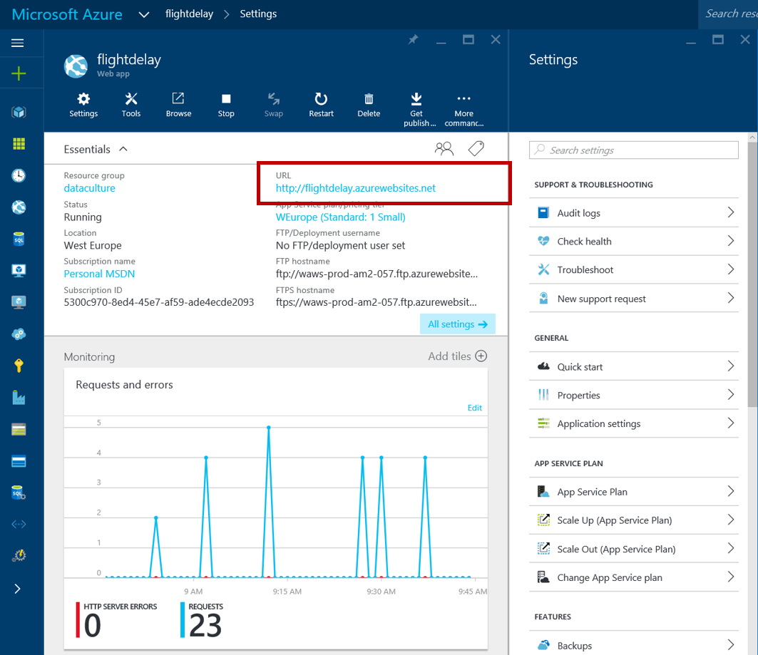

If we then click on the URL of the new site we’ll be presented with a simple page where we can enter our API URL and API key ..

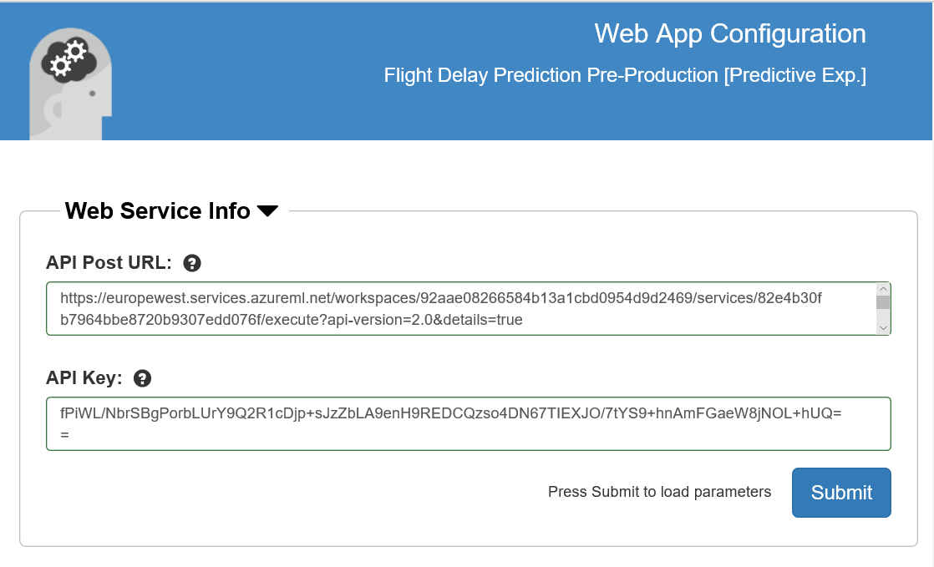

The key is on the API dashboard and the URL is at the top of the Request response page. Click Submit and close the page. Go back to the Azure Portal and open the site again and enter some trial values..

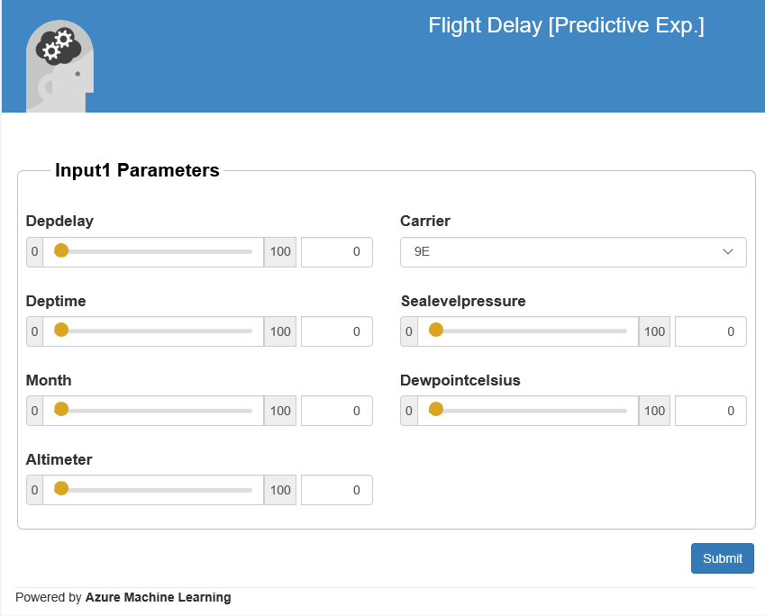

Optional Exercise – using Excel to call the api

We can also see how we can interact witht the new api form Excel, if you have Excel on your machine. Below is what the Excel 2013 version looks like which uses the new Excel add-ins to automatically setup a connection to the API we have and also allows us to use sample data to test.

From the web services page click on the web service and select the right Excel version for your laptop

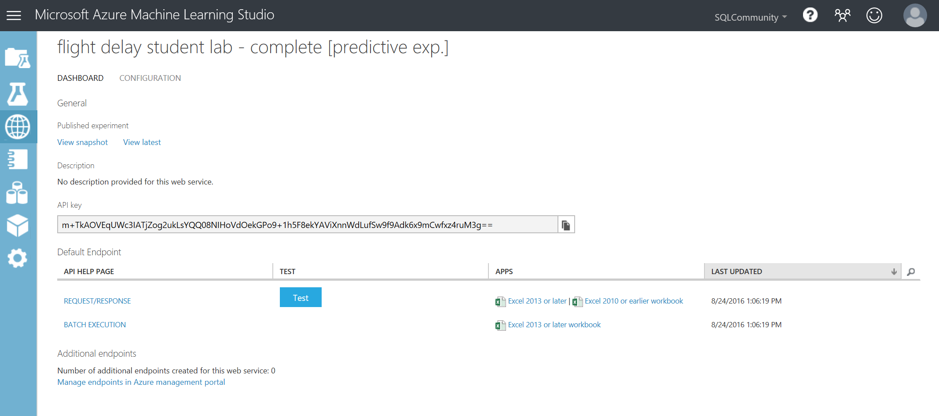

Open the spreadsheet once it’s downloaded:

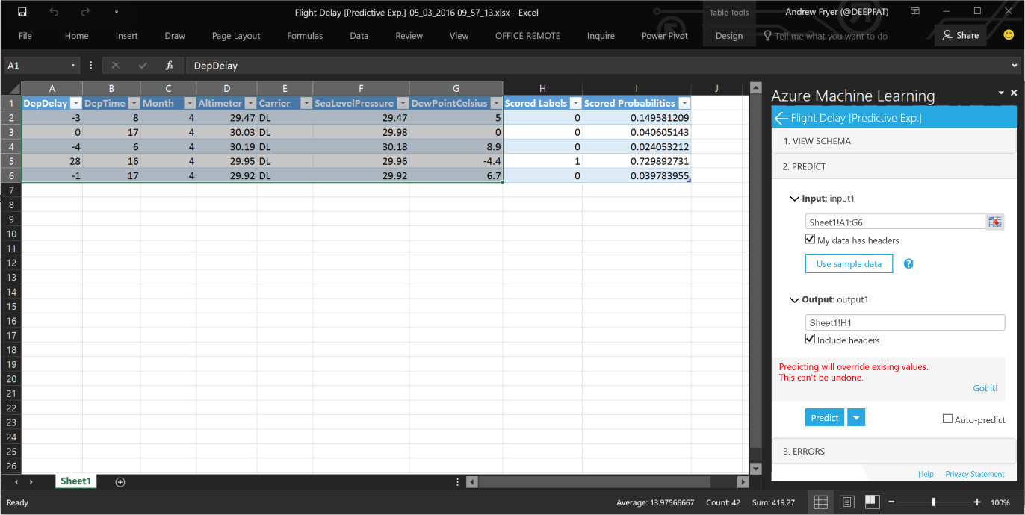

Click on sample data in the Azure Learning pane on the right. Select the sample data as Input rows and H1 as the Output and click Predict. You should see the new columns for Scored Labels and Scored Probabilities.

Conclusion

This lab was intended to introduce you to the basic concepts of Machine Learning such as binary classification, feature selection, training and testing a model and using Azure Machine Learning. A web service was created to operationalize and deploy the model for production.

**Next Steps:**

* Check out the UK Data Developer page on MSDN here:
* Check out the Azure ML Gallery and download and edit/run other types of machine learning experiments: <https://gallery.azureml.net/>
* Also check out other Azure Services that can be used with Machine Learning such as HDInsight, Data Factory and Stream Analytics: <http://azure.microsoft.com/en-us/services/>